**Front - End Assignment**

**Part 1 : Web Designing**

**Module – 5 : JQuery Basic, Effects & Advanced**

1. **What is JQuery ?**

* JQuery is a popular JavaScript library that simplifies web development. It provides asset of ready-to-use functionsand features, making it easier to interact with web pages and create dynamic effects. Think of it as a toolbox for developers accomplish common tasks in a more straightforward way.

With JQuery you can easily manipulate HTML elements, handle events (like clicks or form sybmissions), animate elements, make AJAX requests to fetch data from a server without refreshing the page, and much more. It abstracts away many of the complexities of raw JavaScript, allowing developers to write less code and achieve the same results.

One of the main advantages of JQuery is its cross-browser compatibility.

Overall, JQuery is a powerful tool for web developers that simplifiles the process of creating interactive and angaging websites. It’s a valuable asset for both beginners and experienced developers alike, helping them save time and write more efficient code.

1. **Hot to Apply CSS Using JQuery, How to Add Class and Remove Class in JQeury, JQuery Animation ?**

* **Applying CSS using JQuery** :

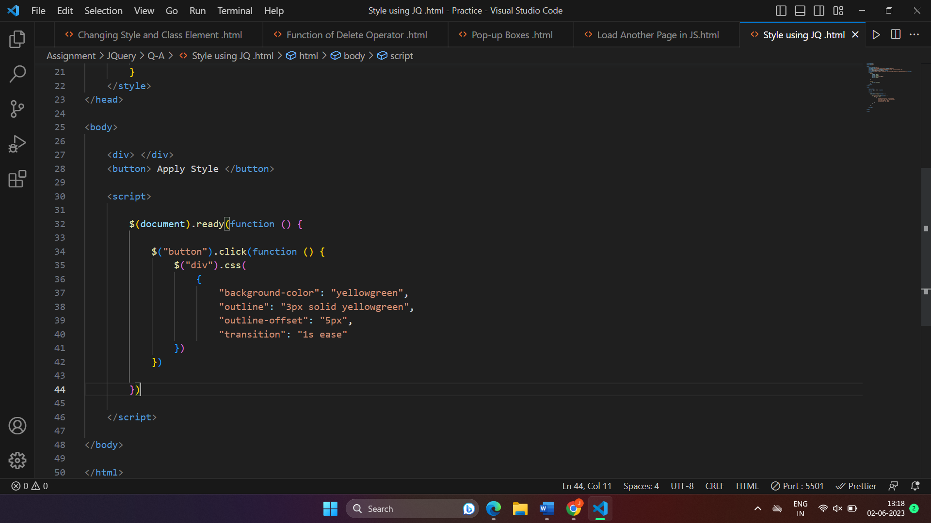

**Add Class in JQuery** :

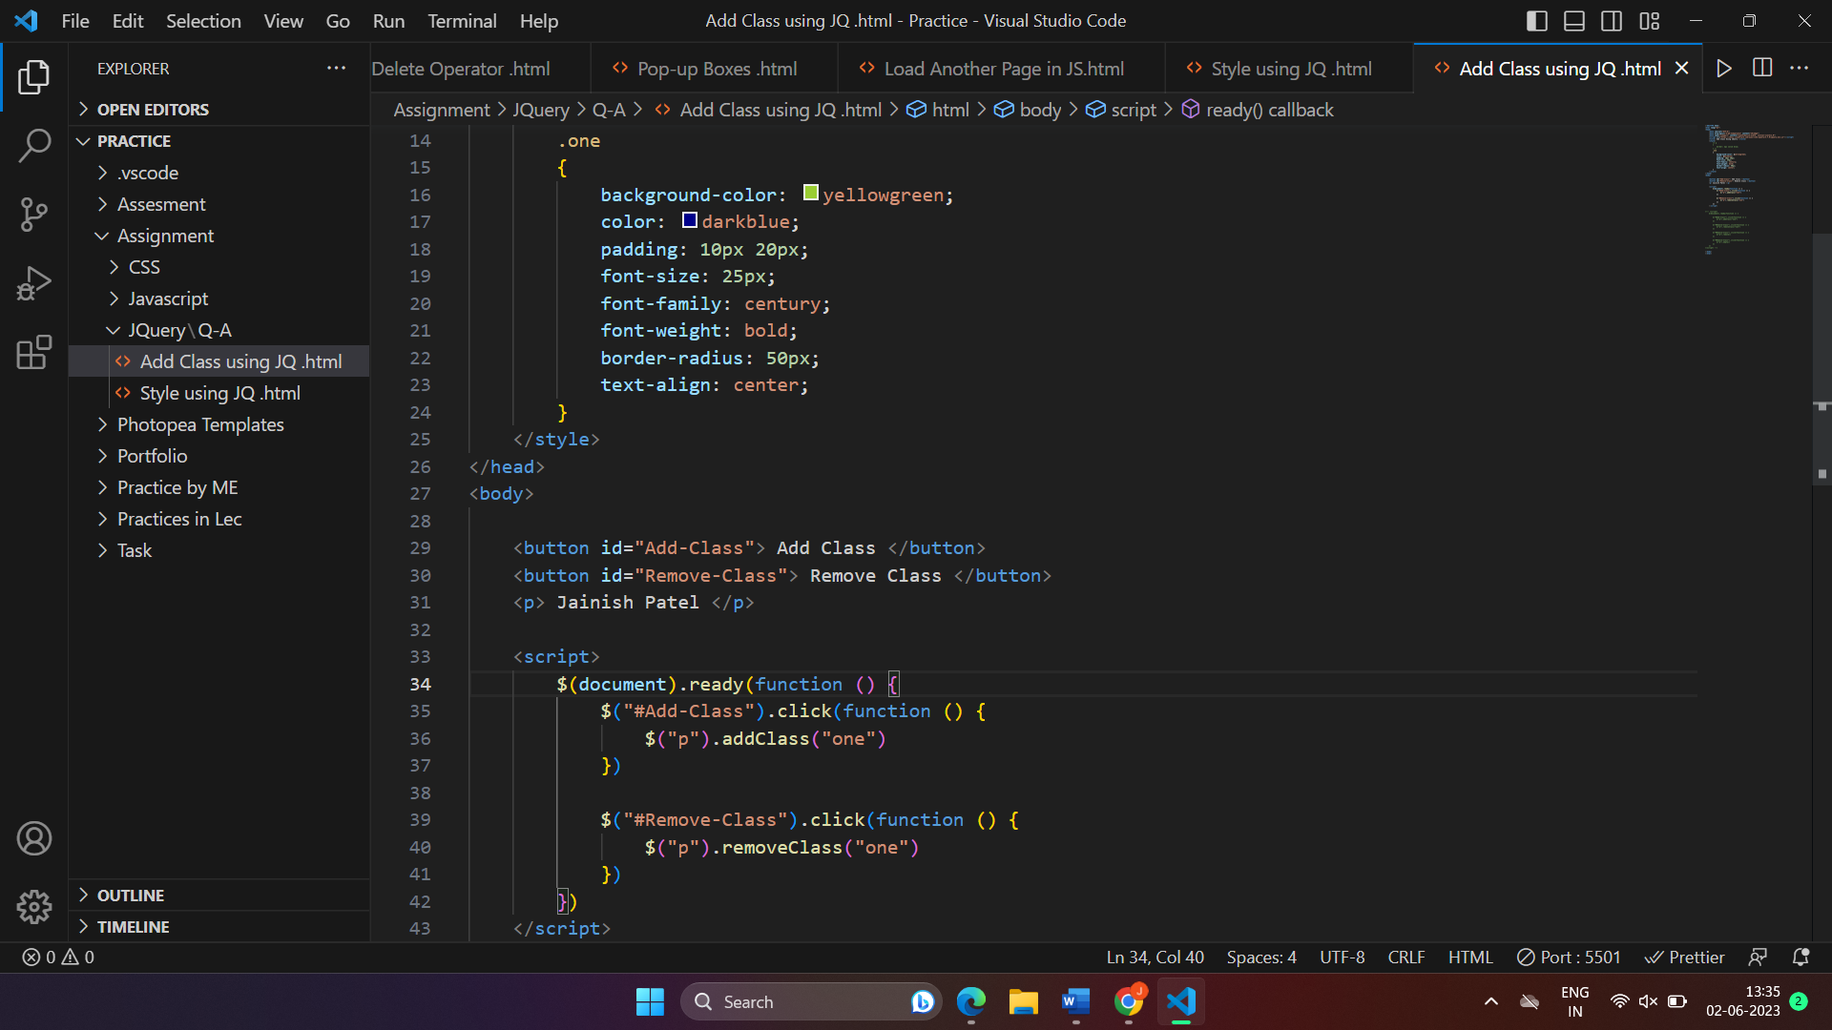

**Animation Using JQuery** :

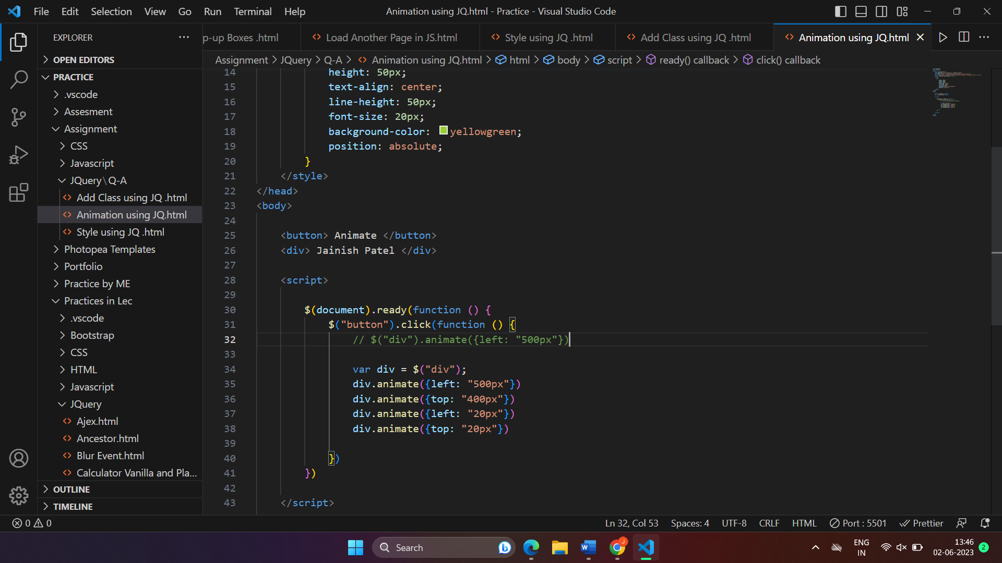

1. **How to create slider with animation ?**



1. **Event bubbling tickling example :**



